GRADE 1. WEEK 34
WORKSHEET: REVIEW 2. Unit 4- 6

1. Read and circle the correct pictures

1. I have two sandwiches 2. They are tigers

3. This is my nose 4. I like crocodiles

5. These are my arms 6. I have an apple

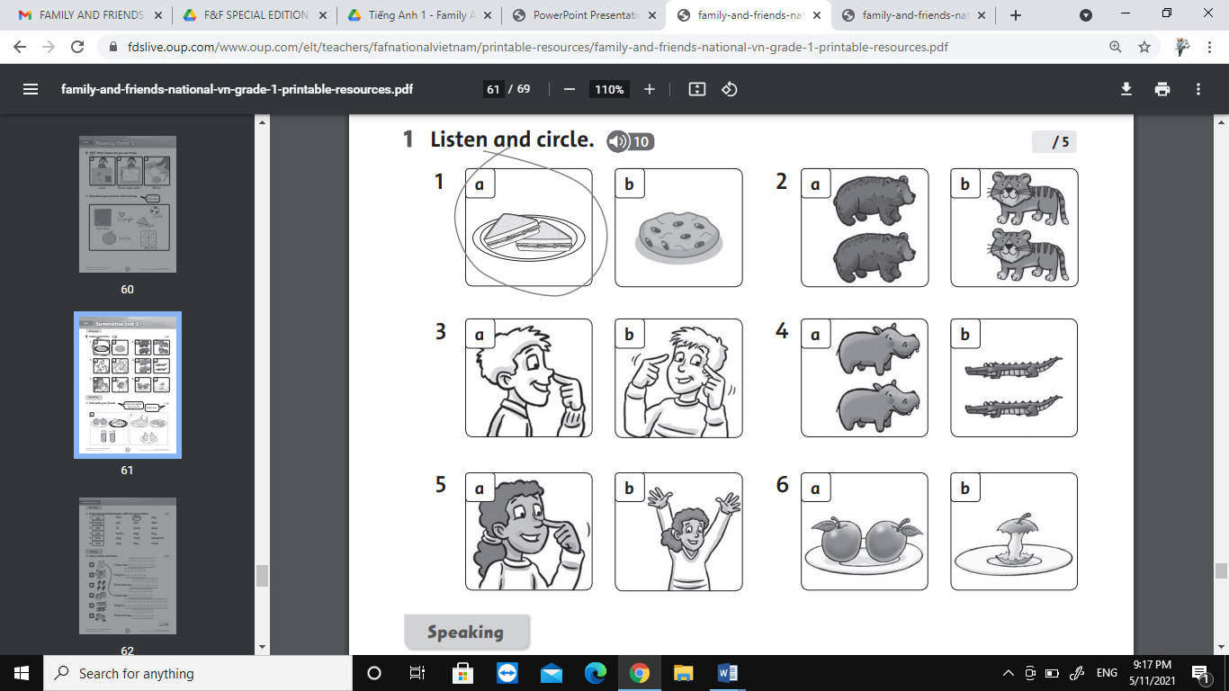
2. Look, match and trace
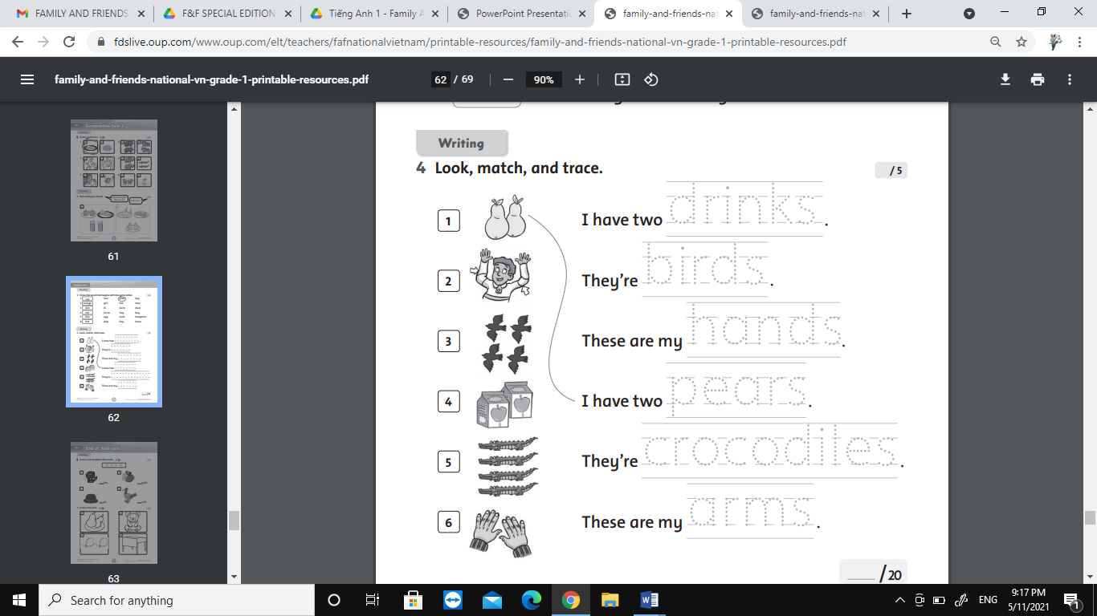

3. Write the numbers: Five ten seven six eight nine
